**Input file:**

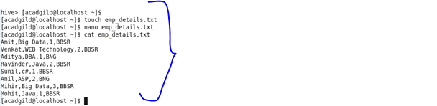

**Creating table and loading data:**

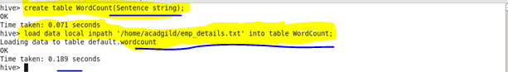

**Split command:**

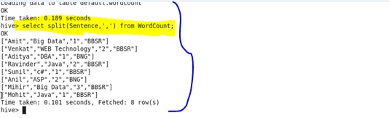

**Explode command:**

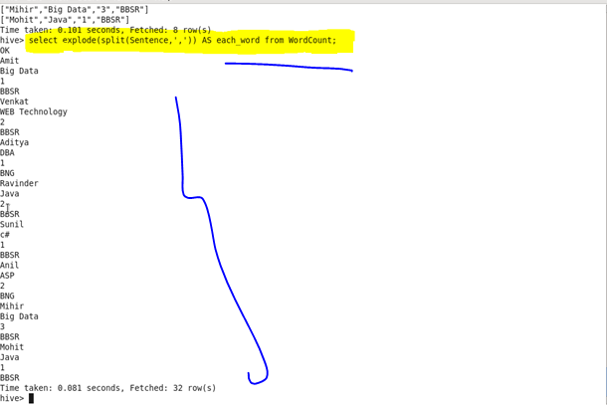

**Counting each word:**

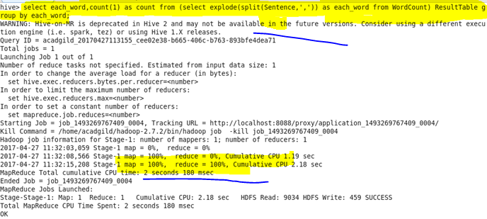

**Output :**

